# What Do YOU Need to Do to Become a Developer? A Deep Dive into StackOverflow’s Developer Survey

[Muhammad Fasih Khan](https://muhammadfasihk.medium.com/?source=post_page-----115c0e4bb940--------------------------------)

#### **[Muhammad Fasih Khan](https://muhammadfasihk.medium.com/?source=post_page-----115c0e4bb940--------------------------------)**

#### **[3 days ago·6 min read](https://muhammadfasihk.medium.com/what-do-you-need-to-do-to-become-a-developer-a-deep-dive-into-stackoverflows-developer-survey-115c0e4bb940?source=post_page-----115c0e4bb940--------------------------------)**

Crunching data to understand what it takes to become a professional software developer.

A picture of a software developer sitting in front of a computer screen



Credits: [Pixabay](https://cdn.pixabay.com/photo/2018/06/08/00/48/developer-3461405_960_720.png)

Becoming a software developer is not easy. Students need to excel in one or more programming languages and master multiple frameworks to land a job. The gap between what students learn at university versus what the industry demands, makes it even more difficult for them.

To understand what it takes to become a professional software developer, I have analyzed a comprehensive survey conducted by StackOverflow. StackOverflow is a popular Q&A website, where veteran programmers interact and discuss solutions for programming problems.

By analyzing the survey, I will look at what these experts consider the best way to break into the world of software development today.

# ****Diving into Data****

Our journey starts with **[StackOverflow’s Developers Survey](https://www.kaggle.com/stackoverflow/so-survey-2017),**where we will see what StackOverflow users have to say.

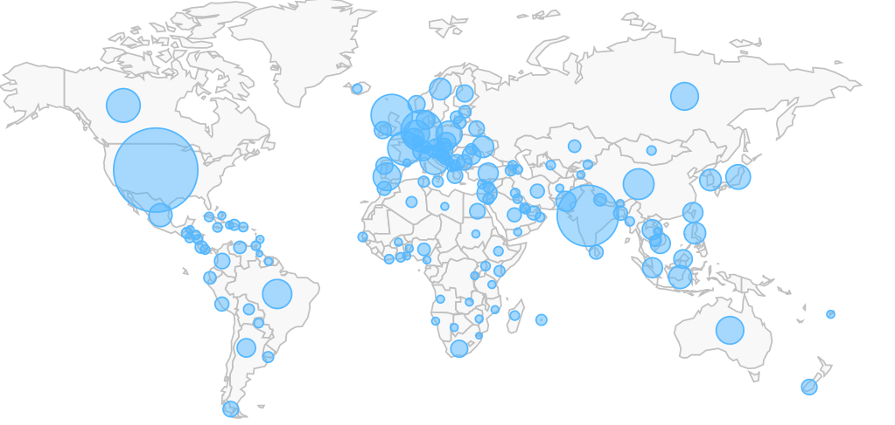

Credits: [StackOverflow](https://insights.stackoverflow.com/survey/2017)

The extensive survey featured more than 50,000 participants from 201 countries and regions. Developers from the United States responded to the survey the most, making up **22.29% of the total respondents**. Developers from India (**10.11%**), the United Kingdom (**8.55%**), Germany (**8.1%**), and Canada (**4.34%**) also contributed heavily to the survey.

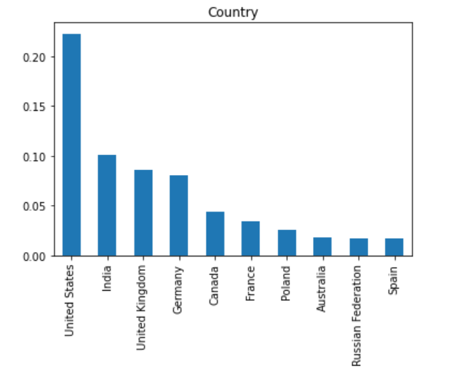

**More than 70%**of the respondents were either working as professional developers or had worked as developers before. Since we seek advice on how to become professional developers, we will only focus on what current and former professional developers had to say.

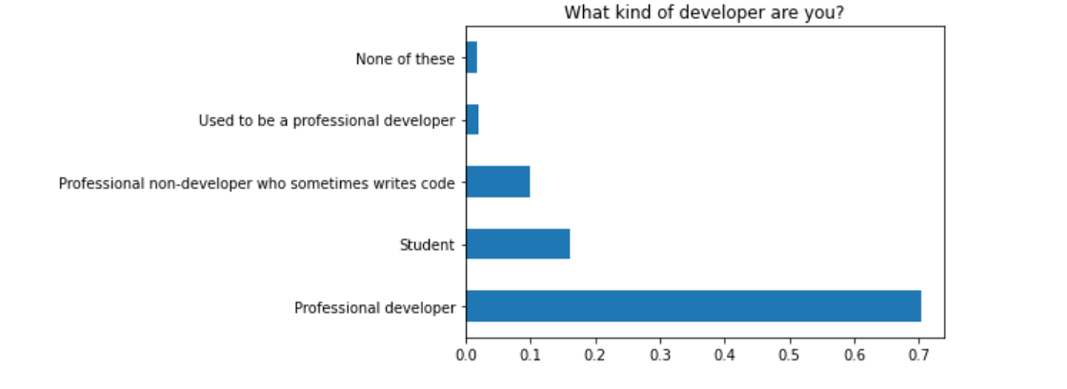

# What formal education do most professional developers have?



Credits: [Tenor](https://tenor.com/view/they-want-us-to-go-back-to-school-south-park-pandemic-special-s24e1-s24e2-gif-19439336)

According to the data, **47.64%** of professional developers in the survey graduated with a Bachelor’s degree and **25.01%**completed a Master’s degree.

Interestingly, a significant portion (**15%**) of respondents were working as professional developers without finishing their Bachelor’s degree. At the same time, **7.5%**of the professional developers in the survey did not even attend college. Therefore, **22.5%** of the respondents proved that you can become a software developer without completing a degree.

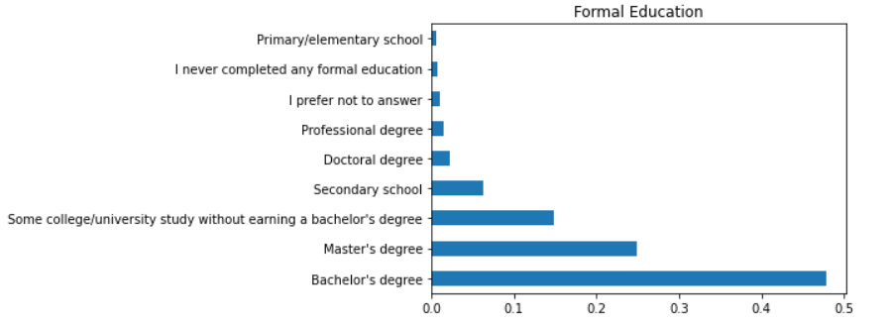

Moving on, the data also shows that respondents with doctoral degrees featured proportionately higher as professional non-developers who coded occasionally.

Although respondents with doctoral degrees comprised only **2.5%**of total respondents, they constituted **7.68%** of professional non-developers who sometimes write code.

# What is the best way to break into software development?

When asked about what’s the best way to break into the field of software development, respondents had differing views.

**Approximately 21% of professional developers**suggest taking online courses is the best way to enter the field of software development.

Students today are often deprived of practical skills during academic studies. Instructors in online courses bridge this gap by teaching students new technologies, frameworks, and in-demand skills in the software industry. However, with the variety of online courses available today, finding the right course is not easy.

**16.1% of professional developers recommend studying textbooks and solving exercises**is also a great way to gain the skills required in the industry. Mind you, these books aren’t the typical textbooks students study for academic degrees, but books that teach us how to best utilize trending technologies.

Experts publish these books for specialized technologies and frameworks to help beginners. They contain several useful exercises that refine the reader’s understanding and helps them leverage new tools more effectively.

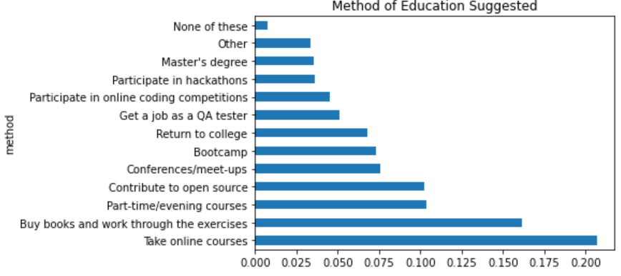

Part-time and evening courses serve the same purpose as the previous two options. In these courses, students interactively learn essential industry skills by implementing programming concepts practically. No wonder, **10.36%** of professional developers suggest these courses for breaking into software development.

**10.24% of respondents suggest contributing to open-source projects**to break into software development. **4.51%**of professional developers recommend participating in online coding competitions to hone coding skills, whereas **3.59%**had a similar opinion about participating in hackathons.

This makes sense logically too. Since most software development roles require refined programming skills, it’s important to practice coding in open-source projects, hackathons, and online coding competitions.

Lastly, attending conferences and meetups can also be excellent for networking. 7.56% of industry professional recommend meeting industry professionals and seeking opportunities in person for earning an entry-level position.

# Is higher education recommended to break into software development?

Usually, a Master’s degree is an excellent choice for specializing in a field and gaining relevant expertise. However, the results here are a little different.

According to the survey, the Master’s degree is not one of the most efficient ways to break into the world of software development.

Respondents from the survey advise learning practical skills instead of investing in higher education. This goes on to show how different software development is compared to other fields.

Upon further analysis, you will find that professional developers with Master’s degrees were biased at suggesting Master’s degrees to others.

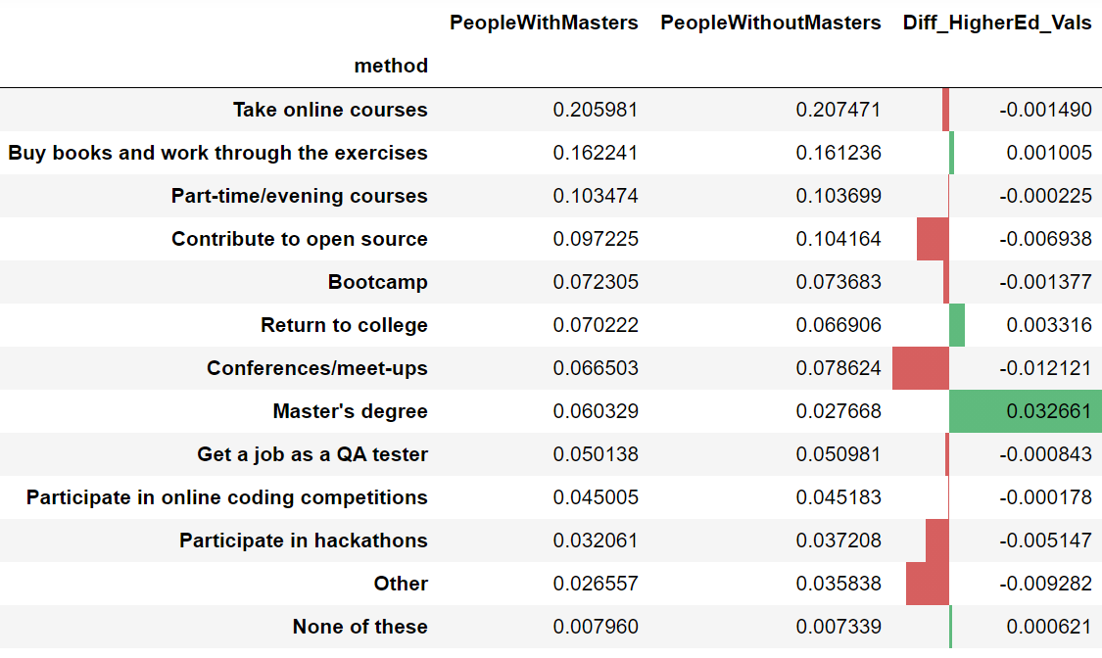

Out of all the professional developers who recommended a Master’s degree, **68.4%**had completed a Master’s or doctoral degree themselves. In other words, respondents with higher education were **biased at recommending Master’s degrees twice as likely than other professional developers**.



Credits: [Tenor](https://tenor.com/view/the-big-lebowski-jeff-bridges-the-dude-john-goodman-walter-sobchak-gif-5042638)

# Are bootcamps worth it?

Bootcamps are one of the most popular ways to break into the field of software development, especially among students who graduate with a Bachelor’s degree. Despite that, they are only recommended by **7.33%**of professional developers in the survey.

Interestingly, **5%** of survey respondents attended Bootcamps themselves. Let us see how bootcamps helped respondents of the StackOverflow survey.

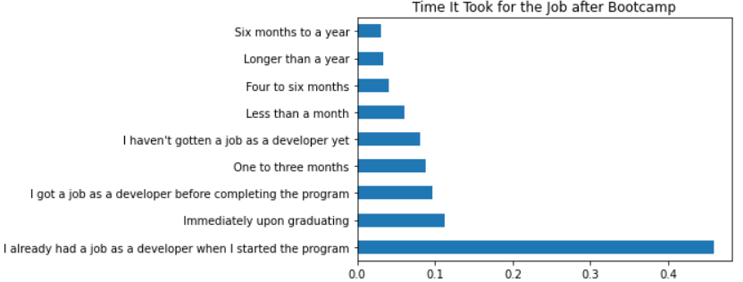

According to the data, approximately **46% of Bootcamp graduates already had a job when they started the program**. Therefore, it’s hard to tell if the Bootcamp helped them get a new role.

**9.68%**of bootcamp graduates secured a development job before they completed the bootcamp, whereas **11.3%**of respondents found a job after completing the program.

At the same time, **6%**of graduates succeeded in finding a job in less than a month, whereas **12.8%** of graduates had to wait between one and six months.

Unfortunately, for **6.26%** of people, it took from six months to more than one year to find a job. Likewise, **8.1%** of graduates didn’t find jobs after completing the bootcamp until the time of the survey.

Bootcamps, in general, seem to help survey participants in landing a job. However, it’s unclear if bootcamps increase earning for professional developers.

Nonetheless, if you’re thinking of joining a bootcamp, it can be a great way to gain hands-on experience and apply programming skills yourself.



Credits: [Tenor](https://tenor.com/view/code-coding-computer-gif-19684211)

# Key Takeaways

Data shows that investing in **Master’s degrees isn’t the most efficient way to break into the world of software development**. That said, the majority of professional developers at least have a Bachelor’s degree. So graduating with a computer science major may improve your chances of becoming a software developer.

Bootcamps are known for training fresh graduates for the industry. The data shows here that **at least 20% of individuals earned a job upon graduating or earlier**. However, it’s still unclear how bootcamps helped people who were already professional developers.

Most veteran software developers in the survey agree that **learning in-demand software development skills is the best way to become a software developer**. Whether you do that by enrolling in part-time, evening or online courses, buying books and solving exercises, contributing to open-source projects, or participating in coding competitions and hackathons. Getting your hands dirty with software projects will help you become a professional software developer in 2021.